Is microcirculation the key to feeling younger?
Do you feel like the tin man or woman in need of an oilcan so you can lubricate every joint and jump in the Fountain of Youth? That was me a year ago, before I started microcirculation therapy. Every day my legs were as tight as tree trunks, and I had severe discomfort. Including cold hands and feet along with a bundle of other symptoms. I am always working to improve my health and learning more about health and wellness. I believe it's a constant journey to find out what works for both me and my clients. In my case, I was getting massages every other week and a regular chiropractic sessions. I even changed my diet. These all helped with some of the issues I was experiencing but I still felt like something deeper was going on inside my body. "If only I could get a full body scan of some kind" I thought, and that's when I remembered a test, I had undergone years ago called Thermography. Thermography is a physiologic test, which demonstrates thermal patterns in skin temperature. Results may either be normal or indicate disease or another abnormality. Thermography provides you with an image you can see in real time and can indicate areas that are afflicted or have improved. This knowledge enabled me to know what was working for me and to make changes to my personal health goals and treatments. On March 10th of last year, I had a full-body Thermography session and I learned that I had peripheral vascular insufficiency - in other words. Poor blood flow. A registered nurse encouraged me to learn about microcirculation, a type of therapy that enhances blood flow and encourages the body to heal itself. The sessions are done fully clothed while lying or sitting on a mat that enhances microcirculation. Movement of blood at the capillary level bring oxygen and nutrients to the cells and tissues. At the same time, toxins and wastes (like carbon dioxide) are removed. I thought "Why not give it a few months, it sounds like what I need." On April 20th, I started to use the microcirculation device at home before introducing it to my clients. After two months and a lot of research, I felt I had increased energy. The cold feeling in my feet and hands seemed to decrease, along with the numbness in my fingers. I no longer felt like a tin woman in need of an oilcan. From July to August, I started to feel phenomenal, with increased endurance, more energy and less discomfort. I began to be more active, too, especially with my family. Now, I'm riding a bike and hiking with them, which I have never done prior. I felt so phenomenal that, on Aug, 22nd I had another thermography session on my legs to see if my results would show up visually. They did! Thinking back to the microcirculation training class I attended last year, I wanted to share this story. At that training session, I felt like I was in the movie "Cocoon" watching older attendees demonstrate how they felt younger as they did squats, jumps and stretches. It made me smile. Now, I realize that I feel young too.
Do your joints need oiled? Do you want to feel like you've found the Fountain of Youth? Check out our website and find out if microcirculation is for you!
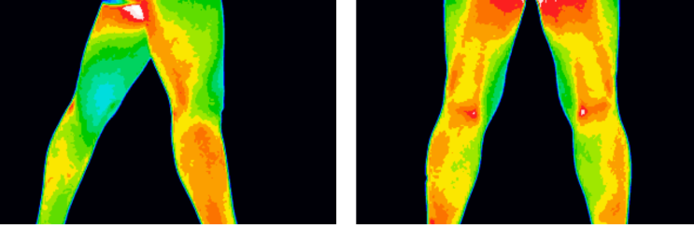
Renee Swasey Thermography results prior to microcirculation (1st photo taken 3.10.2019) the 2nd photo shows her results after trying microcirculation for 5 months and the 3rd photos are the most recent Thermography take from 1.30.2022
3.10.2019

9.22.2019

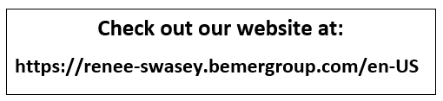
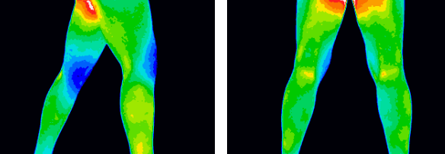
Microcirculation Prices:
12 Sessions - $180
24 Sessions = $300
Recommendation 3x per week for 6 weeks for best results
Rental Units Available through AMTM
6 Week Rental $300
1.30.2022

